**Sprint 1 Plan - RetailGo - 10/20/23**

Goal: Set up store registration, authentication, and inventory interface for RetailGo.

**Task listing:**

* **User Story 1:** As an owner, I want to register my store so I can manage my store from my computer.
  + Architecture Design (4)
  + Signup/in page design (1)
  + Implement signup/in UI (5)
  + Implement authentication/account creation to preserve registration of store for future logins. (4)
  + Design RetailGo Database (3)
  + **Total: 17 hours**
* **User Story 2:** As an Owner I want to be able to upload or delete items from my inventory.
  + Inventory UI design (1)
  + Implement UI for viewing inventory; simple grid view of inventory items (5)
  + Implement inventory-related CRUD operations for authenticated users (5)
    - **Total: 16 hours**
* **User Story 3:** As an employee, I want to be able to view the inventory to manage stock levels on shift.
  + Reflect Read permission of employee on UI (1)
  + Add Read Inventory Route in Golang Backend (1)
    - **Total: 2 hours**

**Team Roles:**

* David Nguyen -> Developer
* Apramay Singh -> Developer & Product Owner
* Jonathan Michel -> Developer
* Leo Asatoorian -> Developer & Scrum Master
* Giridhar Vadhul -> Developer
* Colby Frey -> Developer

**Initial Task Assignment:**

* David Nguyen - (User Story 1) Clerk authentication for signin/signup
* Apramay Singh -> (User Story 1) Architecture Design
* Jonathan Michel -> (User Story 1) Backend Database Design
* Leo Asatoorian -> (User Story 2) UI/UX: Inventory Page Design
* Giridhar Vadhul -> (User Story 2) CR routes
* Colby Frey -> (User Story 2) Inventory Interface Frontend

**Initial burnup chart - Sprint 1**

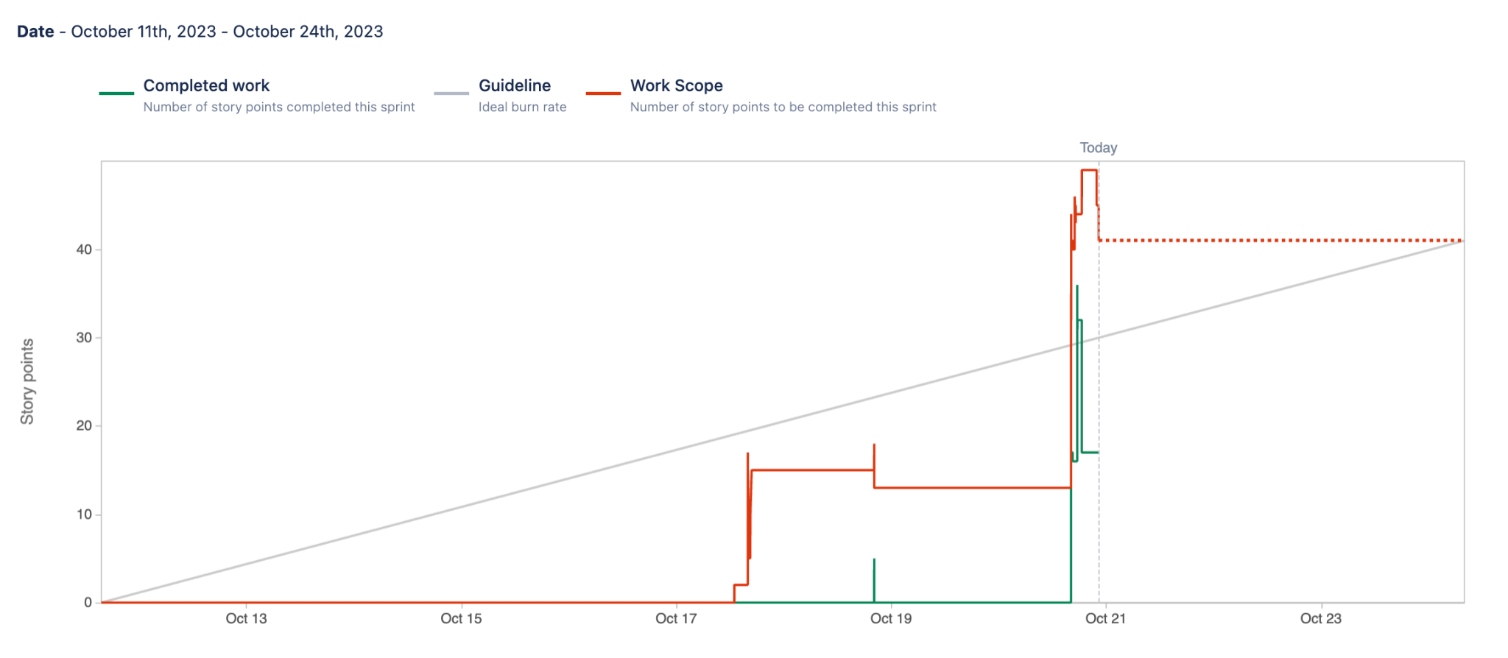

**Initial scrum board**

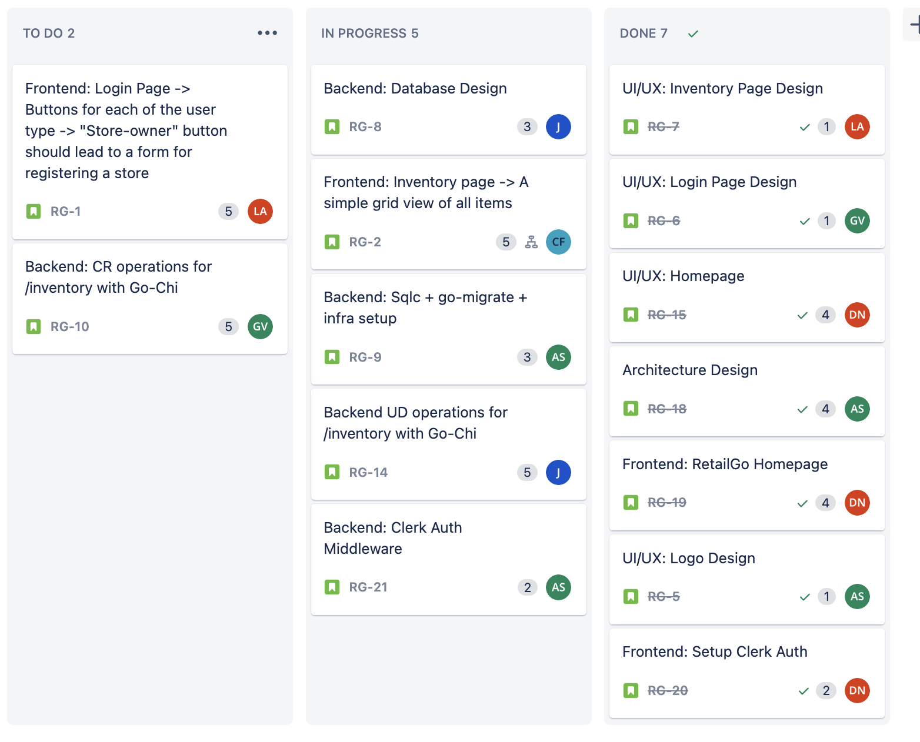

**Scrum Times:**

* Monday -> 4-6pm -> TA tutor visit
* Thursday -> 4-5pm
* Saturday -> 2-3pm